# Preguntas Objetivo 2

## Pregunta 1

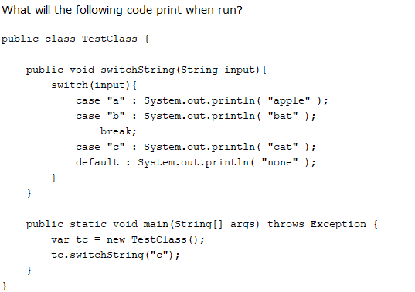

A. apple

cat

none

B. apple

cat

C. cat

none

D. cat

## Pregunta 2

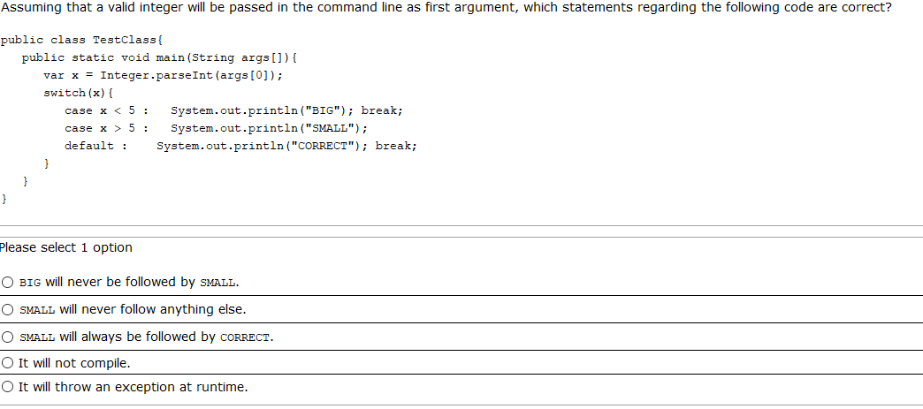

## Pregunta 3

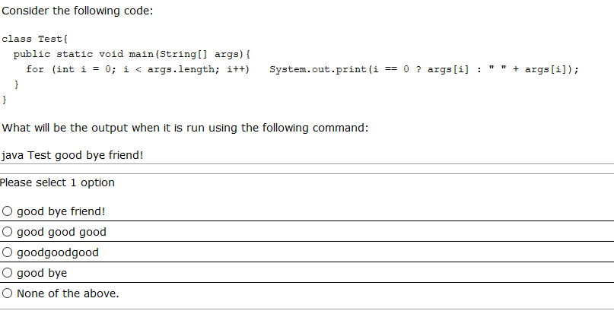

## Pregunta 4

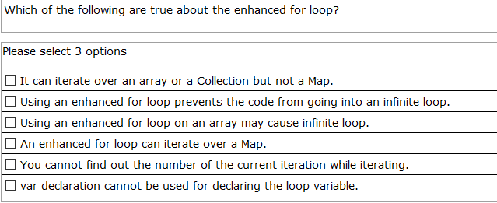

## Pregunta 5

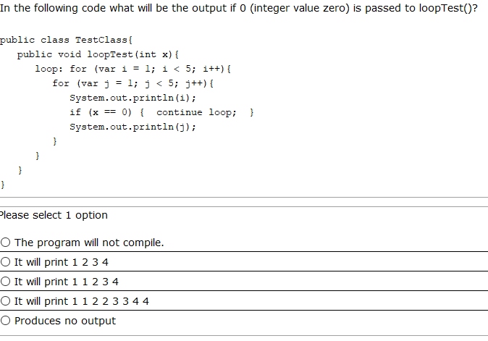

## Pregunta 6

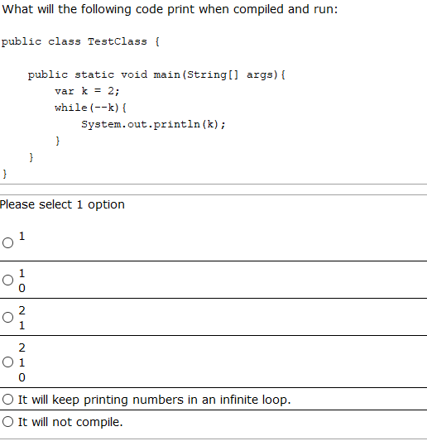

## Pregunta 7

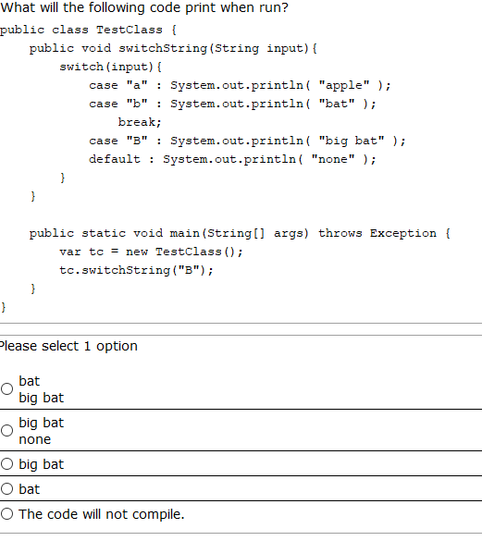

## Pregunta 8

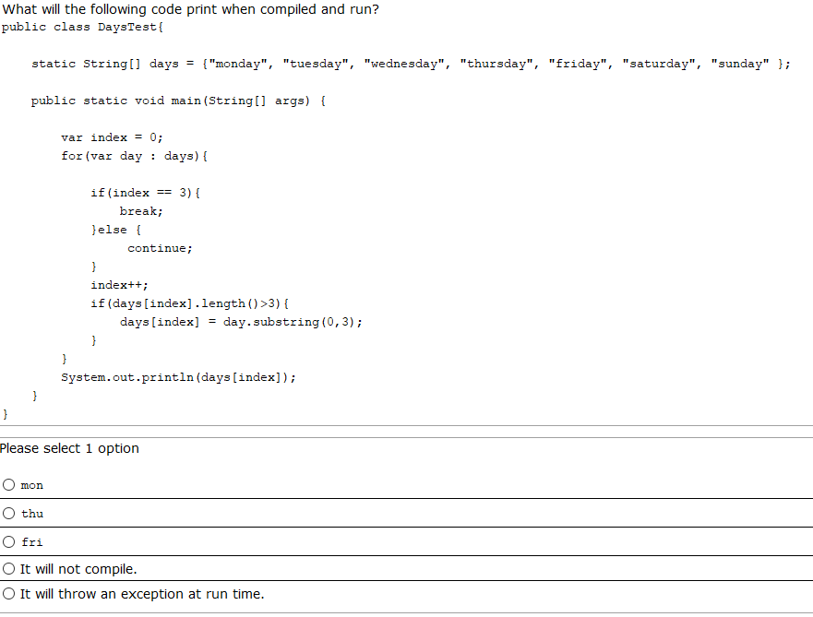

.

## Pregunta 9

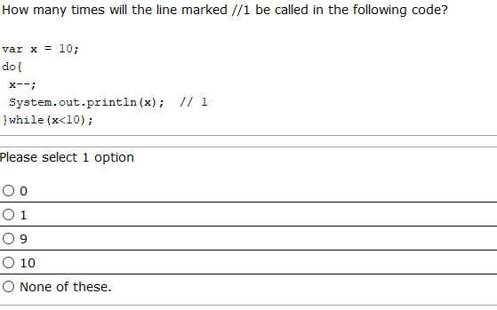

## Pregunta 10

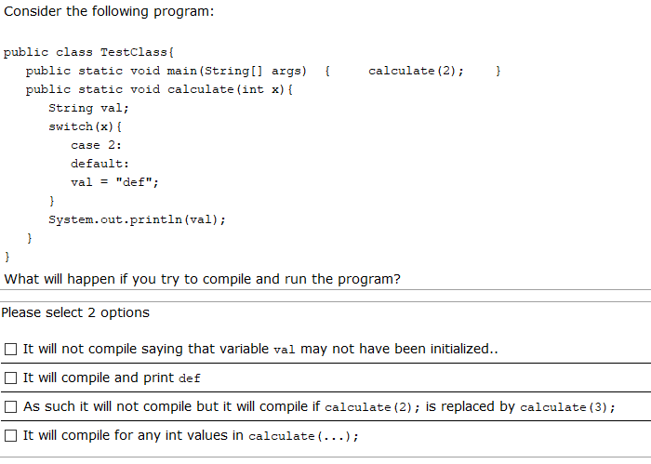

## Pregunta 11

Given the following:

class A{

public void testA(){System.out.print("Is A ");}

}

class B extends A{

public void testB(){System.out.print("Is B ");}

}

class C extends B{

public void testC(){System.out.print("Is C ");}

}

And the following:

A ob=new C();

if(ob instanceof B b){

b.testB(); //line 1

}

if(ob instanceof C a){//line 2

a.testC();

} else{

ob.testA();

}

What is the result?

A.Is C

B.Is A

C.Is B Is C

D.It prints nothing

E.Compilation fails at line 1

F.Compilation fails at line 2

## Pregunta 12

Given:

public static void main(String[] args){

Integer data=10;

int n=2;

switch(data/n){

case 1,3->System.out.print("low ");

case 4,5-> System.out.print("medium ");

case 6,7,9-> System.out.print("high");

}

}

What is the result?

A.medium

B.medium high

C.A runtime error is thrown.

D.Compilation error.

## Pregunta 13

Given:

String cad="""

h

""";

System.out.println(switch(cad.indent(1).length()){

case 1->"simple";

case 2,3->"normal";

case 4->"optimal";

});

What is the result?

A. simple

B. normal

C. optimal

D. Compilation error

## Pregunta 14

Given the following:

public class Test {

public static void main(String[] args) {

int x=100;

int a=x++;

int b=++x;

int c=x++;

//a=100, b=102, c=102

int d=(a>b)?(a<c)?a:(b<c)?b:c:b;

System.out.println(d);

}

}

**What is the result?**

A. 100

B. 102

C. 101

D. 103

E. Compilation will fail.

## Pregunta 15

**public** **class** Test {

**public** **static** **void** main(String[] args) {

**for**(**var** i=0;i<=5;i++) {

**var** res=**switch**(i%5) {

**case** 2->i*=i;

**case** 3->i++;

**case** 1,4->i--;

**default**->i;

};

System.***out***.print(res);

i++;

}

}

}

**What is the result?**

A. 3

B. 4

C. 04

D. -13

E. Compilation will fail

## Pregunta 16

**public** **class** Test {

**public** **static** **void** main(String[] args){

**int** s=0;

**int**[][] nums={{2,3,8},{4,1}};

ex: **for**(**int** i=0;i<nums.length;i++){

**for**(**int** k=0;k<nums[i].length;k++){

**if**(nums[i][k]<s){

**continue** ex;

}**else** {

s+=nums[i][k];

}

}

}

System.***out***.println(s);

}

}

**What is the result?**

A. 0

B. 1

C. 10

D. 13

E. Compilation fails

F. The compilation is ok but prints nothing

## Pregunta 17

Given:

public class TestClass{

public static void main(String args[]) {

A ab = new B();

A ac = new C();

if( ac instanceof B b1){

b1.b();

if(b1 instanceof C c1){

c1.c();

}

}else{

ac.a();

}

}

}

class A {

void a(){ System.out.print(" a "); }

}

class B extends A {

void b(){ System.out.print(" b "); }

}

class C extends B {

void c(){ System.out.print(" c "); }

}

What will be the output?

A. a

B. b

C. b c

D. b a

E. Compilation fails